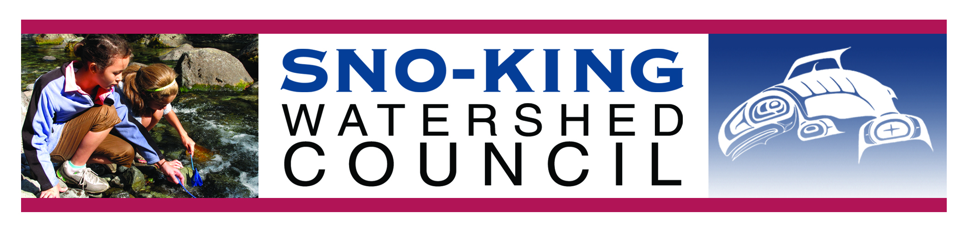
Sno-King Watershed Council Accomplishments in 2015

- 501c3 approved - In 2015, we received formal approval of our 501c3 status.
- Sno-King Water Watchers – a new community-based water monitoring program
  - We received $10,000 in support from the Puget Sound Stewardship and Mitigation Fund, created by Puget Soundkeeper Alliance and administered by the Rose Foundation. An additional $7500 in support came from the Washington Department of Fish and Wildlife Aquatic Lands Enhancement Account (ALEA) grant program.
  - SKWC partnered with Global Water Watch in conducting three days of workshops training volunteer monitors in Physical and Chemical, Bacteriological, and Biological Monitoring.
  - 27 certified monitors spent nearly 500 hours performing monthly monitoring at 24 sites in north King and south Snohomish counties.
- Squire’s Landing Riparian Restoration
  - SKWC was successful in obtaining a $70,000 grant from the Salmon Recovery Funding board for this restoration project in partnership with the City of Kenmore, Adopt A Stream, and Cooke Scientific (Sarah Cooke).
  - Our project partner Adopt A Stream initiated invasive control and mowing on 2 acres at the mouth of Swamp Creek in Kenmore. Planting is scheduled for 2017.
  - We continued to work with the City of Kenmore and the Army Corps of Engineers on a proposal for a larger-scale restoration on this site.
- Snohomish County Airport
  - SKWC has so far successfully appealed and prevented conversion of a 5-acre wetland draining to Swamp Creek into a detention pond in violation of County Code, and compelled the County to withdraw its SEPA Threshold Determination (approval).
  - We are working to correct an illicitly constructed large parking lot that is in violation of the County’s NPDES Permit (stormwater management permit with the Department of Ecology) to compel the County to comply with current stormwater design standards.
  - We have advised the City of Mukilteo about potential impacts to the Japanese Gulch and Big Gulch watersheds in Mukilteo from upgrades to some runways, upgrades which do not follow current stormwater guidelines.
- Hooven Bog
  - This is a 30-acre unique and beautiful peat bog. In 2014 we worked along with project partner Bear Creek Headwaters to persuade Snohomish County to purchase it for conservation and restoration.
  - We attended a celebration event at the Snohomish County Executive’s Office for Randy Whelan, the local property owner who started and continues the fight for protection of Hooven Bog.
  - We continue to work with Snohomish County and project partner Bear Creek Headwaters to ensure that restoration happens according to plan.
- Advocacy
  - Bothell North Creek Fish and Wildlife Critical Habitat Protection Area – SKWC joined local environmental advocates SAVE (Save a Valuable Environment) in asking the City of Bothell to maintain protections in this critical watershed on North Creek. The City had passed an ordinance removing some protections. SAVE appealed to the Growth Management Hearing Board and won. The City appealed, and the latest is that the new City Council voted to drop the appeal. For now, the protections remain in place.
  - In Woodinville, SKWC reviewed a short plat application in the buffer of Little Bear Creek, which the City had appealed, and which nearby residents were concerned with. SKWC appealed the project and the city ultimately denied the permit with the new information provided. The project would have been constructed in the buffer of Little Bear Creek.
  - In Lynnwood, SKWC joined Friends of Greater Norma Beach in an appeal of the Seabrook Heights development, which would have impacted Lund’s Gulch Creek. Fortunately, the City of Lynnwood reached an agreement with the developer and was able to purchase the parcel with Snohomish County Conservation Futures money.
  - In Bothell, SKWC joined with One Bothell to work for the protection of the Wayne Golf Course property along the Sammamish River.
- Participation in local and regional salmon recovery and stormwater efforts
  - SKWC is one of a few non-profit members of the WRIA8 Salmon Recovery Council.
  - SKWC continues to participate in King and Snohomish County Eco-Net networks.
  - We hosted a table at the City of Kenmore volunteer fair in April
- Annual meeting
  - In August, we hosted our annual meeting of local environmental and watershed groups, activists, citizens, and elected officials. This year, we partnered with the Adopt A Stream Foundation to celebrate their 30th anniversary at this event.
A Look Forward to 2016

- More water monitoring workshops
  - We will again be conducting workshops in April and June in conjunction with Global Water Watch to teach water monitoring skills.
- Swamp Creek Watershed Forum
  - Planning for Fall of 2016, this forum will invite streamside landowners, water quality experts, and local governments to talk about the history, value, issues, problems, and solutions associated with this important local creek.
- Continuing our outreach, education, and advocacy
  - We plan to continue our activities on behalf of local streams and watersheds.

