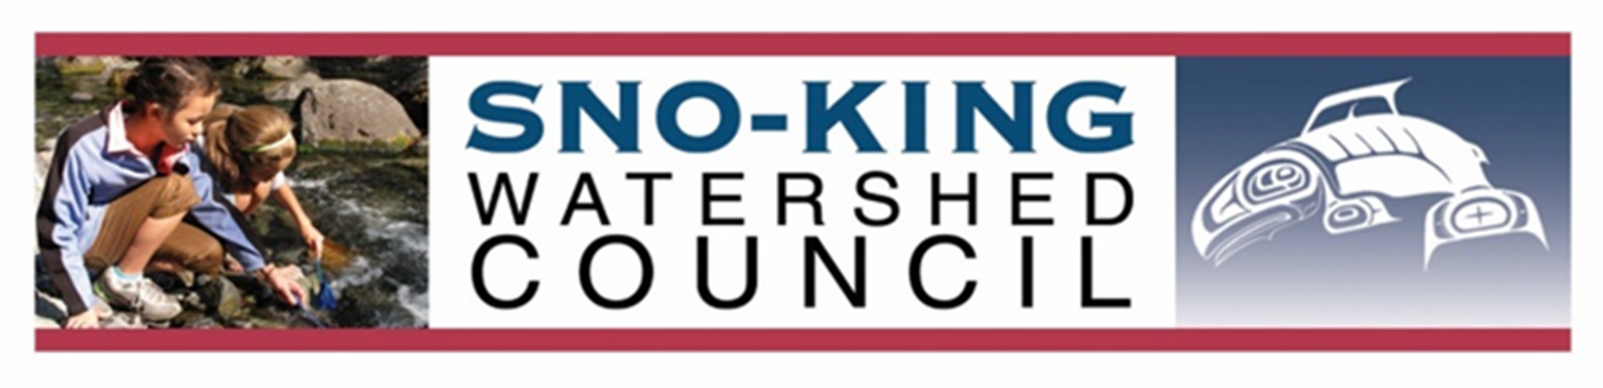

PRESS RELEASE March 27, 2020 FINAL DRAFT

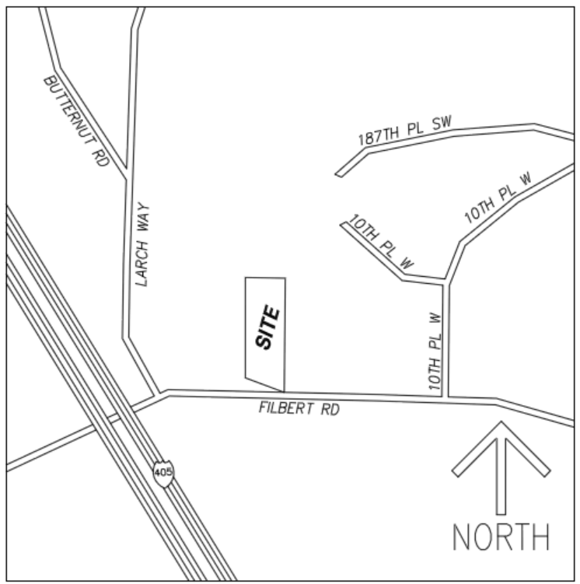
SNOW RIDGE DEVELOPMENT HALTED
On March 26, 2020 Snohomish County Hearing Examiner Peter Camp ruled in favor of Sno-King Watershed Council’s (SKWC) appeal overturning Snohomish County’s Determination of Nonsignificance (DNS) and its approved plans prepared by developer JM1’s for its Snow Ridge development.
Snow Ridge is located on Filbert Road (SR-524), between I-405 between and 10th Place W. In October 2018, William Lider, a professional civil engineer and SKWC board member commented on the potential for landslides resulting from Snow Ridge’s stormwater infiltration on the steep slope immediately above the State highway.
Unfortunately, Lider’s comments were ignored by the developer and by Snohomish County’s Planning and Development Services (PDS). Because PDS refused to address these pertinent comments, SKWC was forced to appeal the Snow Ridge project last December. The County’s Hearing Examiner has now overruled PDS’ SEPA determination and permit approval.
“If not for SKWC’s appeal, the Snow Ridge project approved by the County would have been constructed in violation of County Code, creating a landslide hazard risk to the public using SR-524, and degrading the water quality of Swamp Creek,” Lider said.
In a January 28, 2020 e-mail to PDS, Washington State Dept. of Transportation (WSDOT) geotechnical engineers confirmed Lider’s concerns that the Snow Ridge development would destabilize the hillside stating, “We recommend against supporting the proposed ground water infiltration system as it will have a high probability of causing detrimental effects on the adjacent WSDOT owned slopes along SR524.” The Snow Ridge project cannot move forward without WSDOT’s permission.
As a part of its appeal, SKWC investigated the recently completed Forest of Filbert (FOF) development, immediately east of Snow Ridge. Snow Ridge had proposed to use the FOF driveway for joint access to its development. SKWC determined that downstream flooding and overtopping at the newly constructed Larch Way roundabout was exacerbated by the FOF stormwater detention system, that was permitted by PDS in 2018. While the WSDOT stormwater system is adequate to handle the highway’s runoff, it is not adequate to handle additional stormwater runoff from the FOF development, or even more runoff from Snow Ridge. PDS did not fully review the FOF and Snow Ridge drainage reports prepared by the permit applicants to discover errors made in these reports.
Snow Ridge must now significantly redesign its project to provide required environmental protections that were not included in the original design approved by PDS. “The County is not looking out for the public’s best interest by rubber-stamping permit applications,” Lider said.
SKWC is represented by Bricklin & Newman attorneys in Seattle.
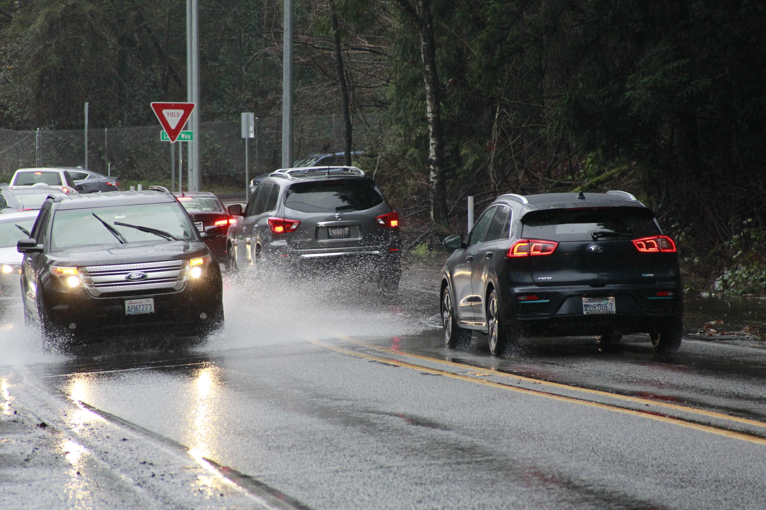Downstream Flooding at Larch Way and Filbert (SR-524) for Forest on Filbert stormwater December 21, 2019:

Photo by William Lider, PE, December 21, 2019

