August 26, 2020

Megan Dunn | Megan.Dunn@co.snohomish.wa.us
Stephanie Wright | Stephanie.Wright@co.snohomish.wa.us
Jared Mead | jared.mead@snoco.org
Sam Low | sam.low@snoco.org
Nate Nehring | nate.nehring@snoco.org

Subject: Proposed County Code Amendments
SCC 30.71.027 – TYPE 1 Permits
SCC 30.72.085 – TYPE 2 Permits

The Sno-King Watershed Council (SKWC) proposes the subject amendments
(Attachment 1) to County Code to prohibit the Director of Planning and Development Services (PDS) from issuing any permits on properties with permits or decisions under appeal, when a timely appeal has been filed, unless subsequently approved by either the Hearing Examiner or County Council.

The August 19, 2020 SKWC letter (Attachment 2) to County Executive Dave Somers describes the problem that arose when PDS issued demolition permits for the Ironwood development, that at the time was under appeal by the SKWC. SKWC, a party of record and appellant of Ironwood, was not notified by PDS that these permits had been issued; we only learned that the permits were issued after demolition was underway from a third-party neighbor, when the demolitions were almost complete.

TRANSMITTED BY E-MAIL

The Ironwood underlying permit for early land disturbing activity (LDA) and SEPA determination approved by PDS, were subsequently withdrawn after SKWC appealed the project, because PDS had illegally approved a phased SEPA review.

In an August 24, 2020 PDS response letter from Michael McCrary, Deputy Director, PDS, he insinuates that it is up to SKWC to check the PDS website daily, to see if any permits have been issued. Mr. McCrary goes on to state that building demolitions are exempt from SEPA. But, by approving the illegal phased demolition work at Ironwood, PDS removed the opportunity to include the existing homes as a part of Low Impact Development re-design at a lower density, that would have met County development requirements for these properties as currently zoned. PDS’s action effectively denied SKWC its right to appeal the Type 2 demolition permit by its failure to notify and affirmed the developer’s phased design.

Page 1 of 2

The filing of an appeal should automatically stay all development work on a property, including issuance of any new permits. SKWC’s timely appeal of the Ironwood was filed at significant cost to our small environmental organization and funded in part by local neighborhood contributions. Citizens and environmental organizations do not have the resources to check every project daily, to see if PDS has surreptitiously issued a Type 2 permit for work that should have been stayed while the project is under appeal.

Mr. McCrary is incorrect that the demolition of the existing Ironwood homes is SEPA exempt; this work is a part of the larger Type 1 decision that was under appeal. The demolition of the homes was a part of the overall Ironwood project, was noted in the SEPA checklist, and is not exempt from SEPA. PDS continues to cling to the illegal notion that work on the Ironwood project may be phased.

To prevent these wrongful permit approvals by PDS from occurring again without notification to appellants or parties of record, we submit the attached proposed change to County Code prohibiting the director from issuing any permits while projects are under appeal for the property.

Representatives of SKWC would be willing to meet or conference with the County Council regarding the proposed code changes.

This code change will affect numerous other pending permits of great public interest such as Snow Ridge, Ambleside, Pinecrest Pointe, and others. Time is of the essence with this code change.

Thank you for your consideration of this letter and proposed code change.

Respectfully submitted,
SNO-KING WATERSHED COUNCIL
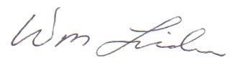

William Lider, SKWC Board Member
2526 – 205th Place SW
Lynnwood, WA 98036
Bill@LiderEngineering.com
425-776-0671

Attachment 1: | Proposed County Code Amendments, SCC 30.71.027 & SCC 30.72.085
Attachment 2: | August 18, 2020 SKWC to Dave Somers
Attachment 3: | August 24, 2020 PDS response to William Lider

cc: Dave Somers SKWC Board of Directors
Page 2 of 2

Proposed Revision to SCC 30.71 – TYPE 1 PERMITS

30.71.027 Review or revocation of certain permits or approvals.
- Upon timely filing of an appeal, the director shall not issue any permits or approvals for any work on the property subject to the appeal, unless approved by the hearing examiner.
- If the director determines that a permit or approval is in material violation of this title, the director may initiate proceedings before the hearing examiner to review or revoke the permit or approval, in whole or in part.
(32) The hearing examiner shall hold a hearing in accordance with SCC 30.71.100. The director shall provide notice in accordance with SCC 30.70.050.
(43) The hearing examiner, upon good cause shown, may direct the department issue a stop work order to temporarily stay the force and effect of all or any part of an issued permit or approval until the final decision of the hearing examiner is issued.
(54) Review or revocation of a shoreline substantial development, shoreline conditional use or shoreline variance permit shall be in accordance with the provisions of chapter 30.44 SCC.
Proposed Revision to SCC 30.72 – Type 2 Permits
30.72.085 Effect of appeal.
- Timely filing of an appeal shall stay the effective date of the hearing examiner’s decision until such time as the appeal is decided by the council or withdrawn.
- Upon timely filing of a Type 1 or Type 2 permit appeal, the director shall not issue any permits or approvals for any work on the property subject to the appeal, until such time as the appeal is decided by the council or withdrawn.

TRANSMITTED BY E-MAIL
August 19, 2020

Dave Somers, County Executive county.executive@co.snohomish.wa.us

Subject: Ironwood Development
Violation of SCC 30.71.027
PDS Malicious Malfeasance

The Snohomish County Planning and Development Services (PDS) and Pacific Ridge Homes (the Applicant) acted maliciously and in bad faith, not notifying myself as the representative of Appellant Sno-King Watershed Council, and other parties of record before issuing the flowing demolition permits while the Ironwood project was under appeal:
- 20-111031 DEMO (parcel 003730-003-018-06)
- 20-111032 DEMO (parcel 003730-003-018-00)
- 20-111033 DEMO (parcel 003730-003-018-01)
- 20-111034 DEMO (parcel 003730-003-010-01)
- 20-111035 DEMO (parcel 003730-003-011-00)
- 20-111036 DEMO (parcel 003730-003-017-02)

The time line of this for this egregious behavior by PDS and the Applicant is as follows:

➢ June 29, 2020 | PDS Issues the Ironwood DNS-SEPA & Administrative Decision PFN:19‐118531‐LDA and 19‐118577‐FPA;
➢ July 22, 2020 | SKWC Appeals the PDS Ironwood DNS-SEPA &
 | Administrative Decision
➢ July 27, 2020 | Diane Swiben, Pacific Ridge Homes applies for 6-demolition
 | permits;
➢ July 27, 2020 | PDS rubber stamps 6-demolition applications and issues
 | permits the same day, in violation of SCC 30.71.027;
➢ August 12, 2020 | PDS Withdraws its erroneous DNS Decision & illegal use of
 | “phased review”;
➢ August 17, 2020 | Hearing Examiner Camp Dismisses the SKWC Appeal and
 | refunds SKWC;s $500 filing fee;
➢ August 17, 2020 | Lider is notified by Ironwood neighbors of ongoing demolition;
- August 17, 2020 Lider/SKWC is notified by Sarah Titcomb, PDS of the demolition permits issuance, after Lider initiates contact; and
- August 18, 2020 SKWC Attorney Bryan Telegin is notified that 21-day LUPA appeal period has lapsed.

All work on this project, including demolition work, should have been suspended until the appeal was resolved, pursuant to County Code SCC 30.71.027. The SEPA threshold determination was based on the premise of home construction to replace demolished structures in the environmental checklist submitted by the Applicant, that included demolition of seven homes.
WAC 197-11-340(2)(a) explicitly states:
“An agency shall not act upon a proposal for fourteen days after the date of issuance of a DNS if the proposal involves:
  - Another agency with jurisdiction;
  - Demolition of any structure or facility not exempted by WAC 197-11-800
(2)(f) or 197-11-880;³”

Yet PDS still issued the Ironwood demolition permits knowing full well that the demolition described in the DNS Environmental Checklist was under appeal. PDS intentionally concealed the Ironwood demolition applications and permits thereby effectively denying the SKWC an opportunity to request the Hearing Examiner to issue a stop work order to temporarily stay the force and effect of the issued demolition permit, until the final decision of the hearing examiner is issued, per SCC 30.71.027(3); or to allow SKWC time to file a LUPA appeal. Had I not been alerted by an observant Ironwood neighbor on August 17, 2020, this code violation still would not have been discovered.
The demolition permit application requires the Applicant to certify that:
I will comply with all provisions of law and ordinances governing this type of construction work, whether specific herein or not.
Obviously neither PDS or the Applicant had any intention of complying with the laws or ordinances governing the stay of all work, including demolition, at the Ironwood project site required because of SKWC’s appeal. PDS has demonstrated that it is not trustworthy to administer this permit and has shown favoritism to the Applicant, tainted the fair permit review process, and thwarted public participation.
Because of PDS’s actions illegally piecemealing the SEPA determination, it can be anticipated that the Applicant will use the demolition of these houses as a, “camel’s nose under the tent argument” that the Ironwood development must now move forward because they have demolished the homes under erroneous permits issued by PDS and must now recoup their expenses.
- The County Executive should direct PDS Director Barbara Mock to immediately suspend all building permits related to the Ironwood project, pursuant to SCC
30.71.027; and
- PDS administration of this permit should be halted and completely removed from PDS’s hands; and an independent outside consultant brought in at the County’s and Applicant’s expense to review and administer future Ironwood permits.
Only this way may a fair review of future permit approval process be provided.
Your prompt response is requested and expected.

Sincerely,
SNO-KING WATERSHED COUNCIL

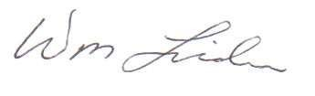

William Lider, PE
SKWC Board Member
2526 – 205th Place SW
Lynnwood, WA 98036
425-776-0671

Bill@LiderEngineering.com

Attachment 1: 2020-08-18 Titcomb e-mail to Lider

cc: SKWC Board
Snohomish County Council contact.council@snoco.org

Barbara Mock, Director, PDS Barbara.Mock@co.snohomish.wa.us

William Lider

From: | Titcomb, Sarah <Sarah.Titcomb@co.snohomish.wa.us>
Sent: | Monday, August 17, 2020 3:13 PM
To: | William Lider
Cc: | JVMirante@pacificridgehomes.com; Countryman, Ryan; McCrary, Mike; Mock, Barb;  Dobesh, Michael
Subject: | RE: Order Closing Appeal: 19-118531 LDA & 19-118577 FPA
Good Afternoon,

Six demolition permits have been issued:
- 20-111031 DEMO (parcel 003730-003-018-06)
- 20-111032 DEMO (parcel 003730-003-018-00)
- 20-111033 DEMO (parcel 003730-003-018-01)
- 20-111034 DEMO (parcel 003730-003-010-01)
- 20-111035 DEMO (parcel 003730-003-011-00)
- 20-111036 DEMO (parcel 003730-003-017-02)

There is also a B4 haul route permit (20-107015 RWB) that appears to have been issued, although this permit is associated with a separate project (Ravenswood, 19-1041818 LDA) and it somehow included the wrong property information. I am currently working to rectify this situation with the Department of Public Works, and it is important to note that the B4 haul route permit for the Ironwood proposal (20-103372 RWB) has not been issued.

The applicant resubmitted materials for a second review of the Ironwood preliminary subdivision and associated LDA (20-102399 PSD/SPA/WMD, 20-102407 LDA) on August 14, 2020. The applicant also submitted a new rezone request to rezone 3 out of the 11 properties from R-9,600 zoning to R-7,200 zoning. (The remaining 8 properties associated with the Ironwood proposal are zoned R-7,200.) Fees for the rezone request (20-102399 REZO) were sent to the applicant earlier today, and once paid, the application will be considered complete and will be noticed in the Herald and sent out in a postcard notice.

Please let me know if you have any further questions or concerns.

Best Regards,
Sarah

Sarah Titcomb | Senior Planner
Snohomish County Planning and Development Services
3000 Rockefeller Avenue M/S 604 | Everett, WA 98201
425-262-2128 | sarah.titcomb@snoco.org

NOTICE: All emails, and attachments, sent to and from Snohomish County are public records and may be subject to disclosure pursuant to the Public Records Act (RCW 42.56)

From: William Lider <Bill@LiderEngineering.com>
Sent: Monday, August 17, 2020 2:19 PM
To: Titcomb, Sarah <Sarah.Titcomb@co.snohomish.wa.us>
Cc: JVMirante@pacificridgehomes.com; Countryman, Ryan <ryan.countryman@snoco.org>; McCrary, Mike
<M.McCrary@co.snohomish.wa.us>; Mock, Barb <Barbara.Mock@co.snohomish.wa.us> Subject: FW: Order Closing Appeal: 19-118531 LDA & 19-118577 FPA Importance: High
1

CAUTION : This email originated from outside of this organization. Please exercise caution with links and attachments. Checking the PDS Map Portal, it indicates that construction is currently underway at the subject Ironwood site.

Please confirm that there are no construction or PDS permits currently active on this site.

Have there been any new permit applications made on the Ironwood property since August 12, 2020?

William (Bill) Lider, PE, CESCL
Lider Engineering, PLLC
2526 – 205th Place SW
Lynnwood, WA 98036
425-776-0671 (W)

From: Yount, Pamela [mailto:Pamela.Yount@co.snohomish.wa.us]
Sent: Monday, August 17, 2020 11:54 AM
To: Bryan Telegin <telegin@bnd-law.com>; Dorsey, Brian <Brian.Dorsey@co.snohomish.wa.us>; Duana Kolouskova <Kolouskova@jmmlaw.com>; Alex Sidles <Sidles@bnd-law.com>
Cc: Kraft-Klehm, Jessica <Jessica.Kraft-Klehm@co.snohomish.wa.us>; JVMirante@pacificridgehomes.com; Titcomb, Sarah <Sarah.Titcomb@co.snohomish.wa.us>; William Lider <Bill@LiderEngineering.com>; Davis, Kris <kdavis@co.snohomish.wa.us>
Subject: Order Closing Appeal: 19-118531 LDA & 19-118577 FPA

To: Bryan Telegin - telegin@bnd-law.com
Brian Dorsey – Brian.Dorsey@co.snohomish.wa.us
Duana Kolouskova – kolouskova@jmmlaw.com Alex Sidles – Sidles@bnd-law.com

Cc: Jessica Kraft-Klehm – Jessica.Kraft-Klehm@co.snohomish.wa.us
J. Mirante – JVMirante@pacificridgehomes.com
Sarah Titcomb – Sarah.Titcomb@co.snohomish.wa.us
William Lider – Bill@LiderEngineering.com
Kris Davis – kdavis@co.snohomish.wa.us

Re: Order Closing Appeal for 19-118531 LDA et al Sno-King Appeal – Ironwood & 19-118577 FPA

Good morning – Please find the Order Closing Appeal attached.

Thank you and best regards,
Pamela Yount

2

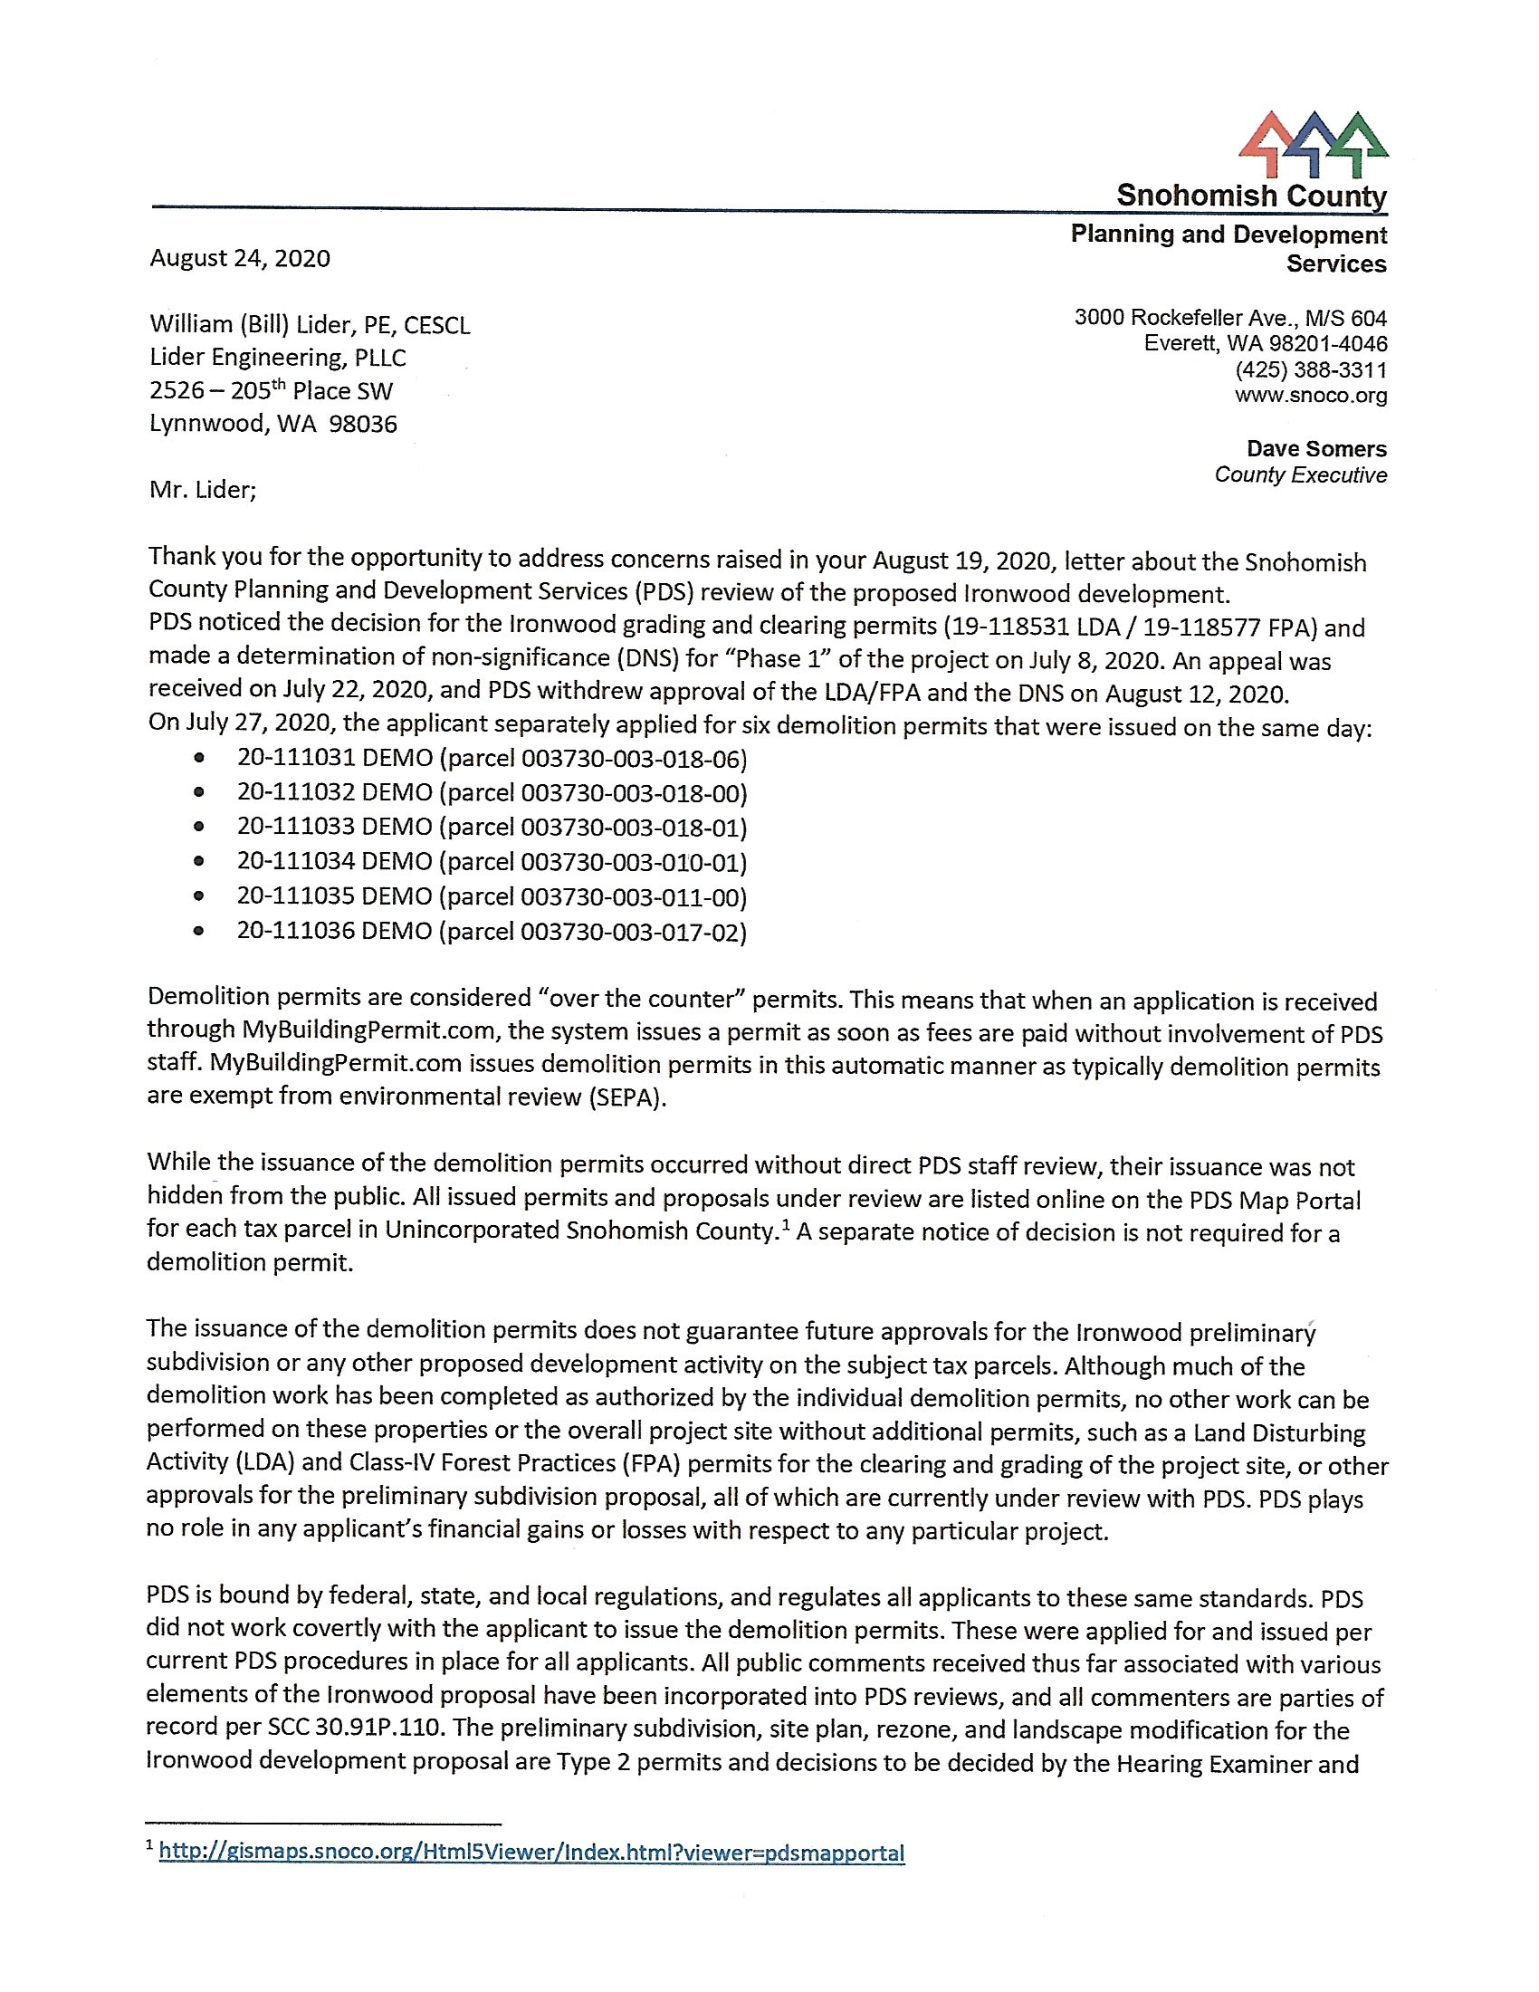
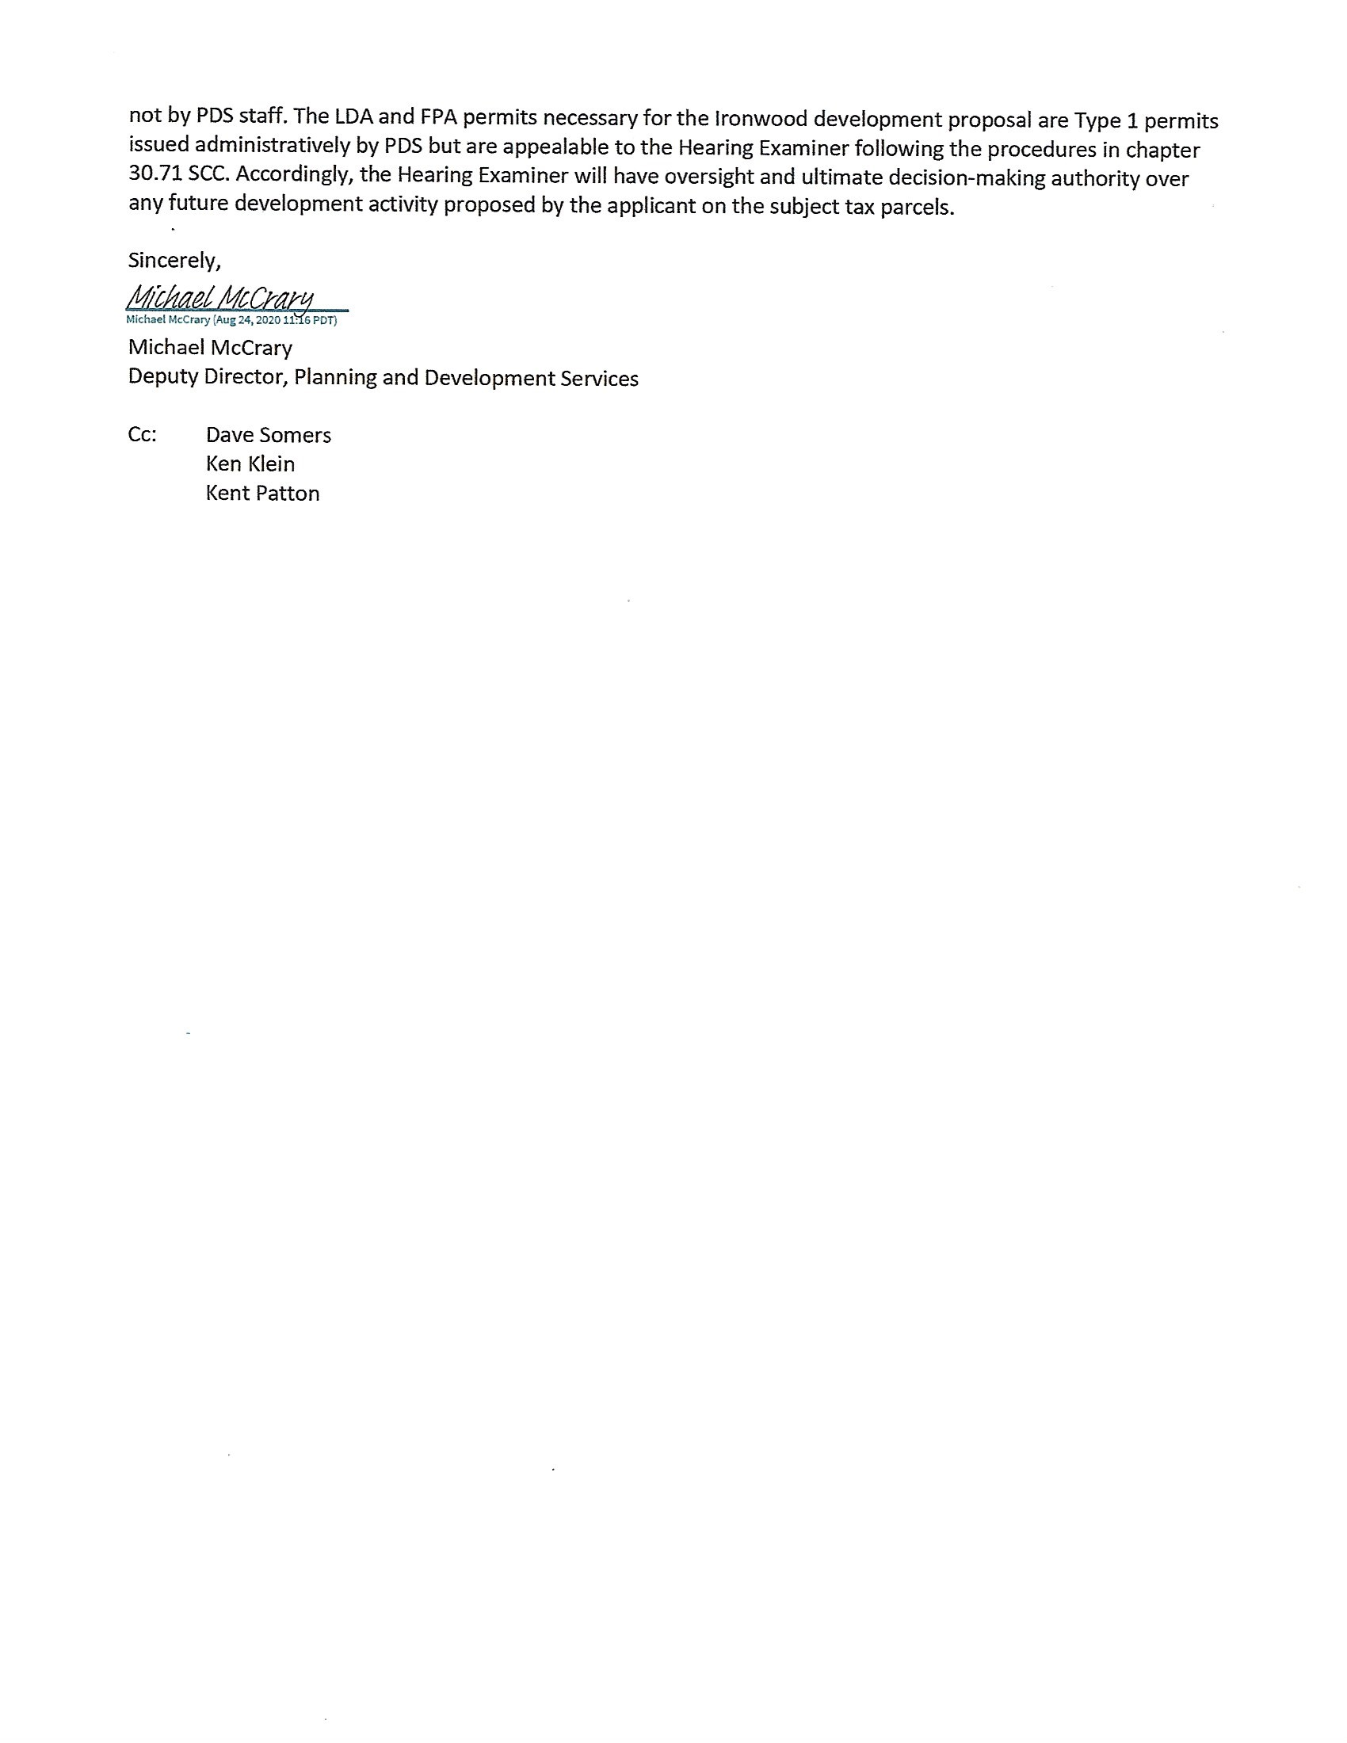
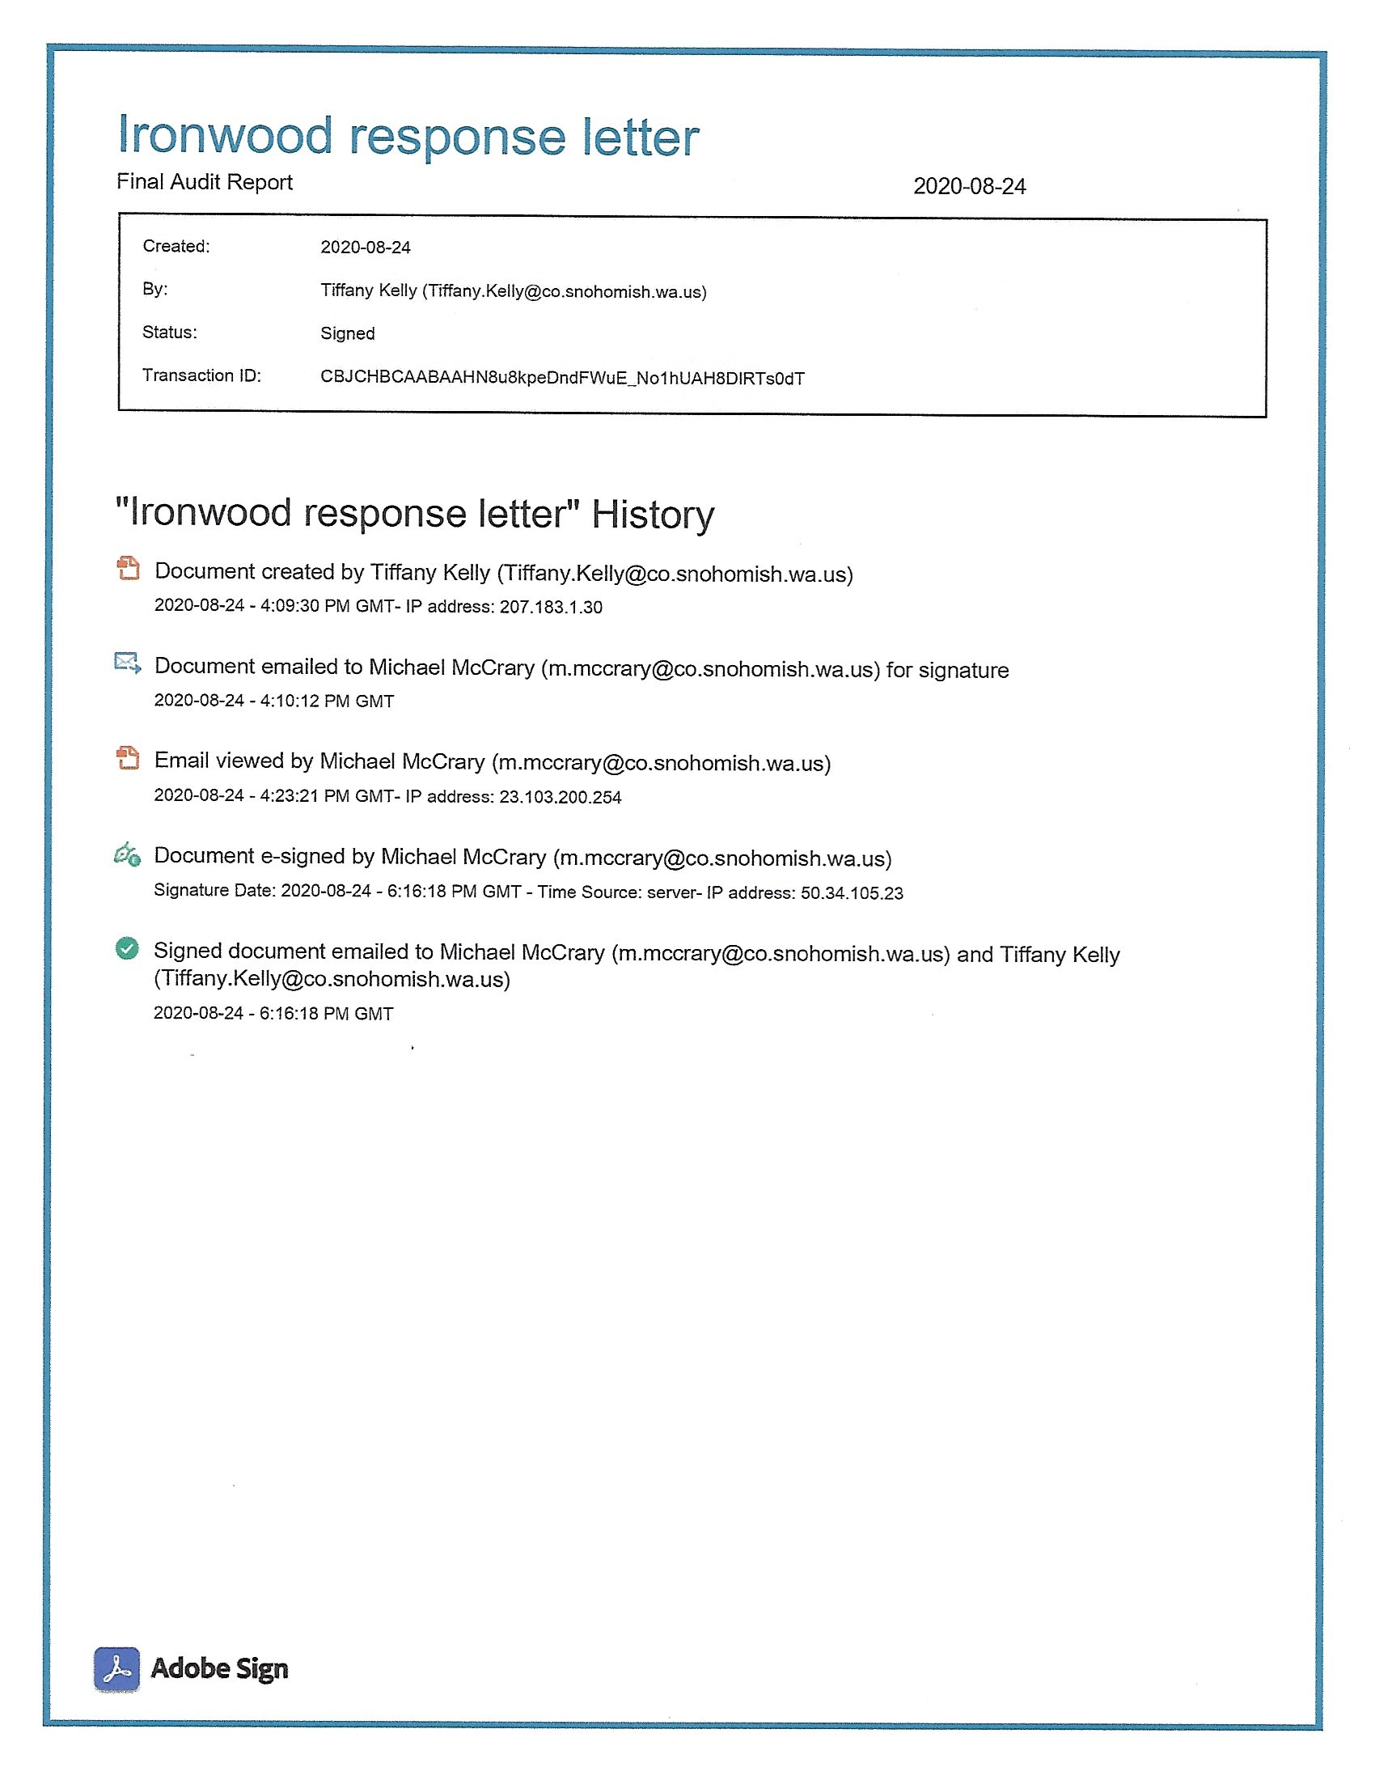

Reference Attachment 1: 2020-08-18 Titcomb e-mail to Lider
Reference SKWC Appeal, Attachment 3, Ironwood PRD SEPA Checklist, Sections 8d and 8j, received by PDS 6/4/20 ³ The requirements of WAC 197-11-800 (2)(f) or 197-11-880 apply only to minor demolition and do not apply in this case.

